

Amy Kellogg
(615) 452-7761
akellogg@tnuct.com

FOR IMMEDIATE RELEASE
January 6, 2011
Weatherford Writes Prize-Winning Essay

Nashville, TN- For the second year in a row, Lakewood Middle School teacher Beth Weatherford has written a prize-winning essay in the statewide Utrust writing competition. She wrote about how Lakewood Middle School reading and language teacher, Susan Parker has made a difference in students’ lives. She said that Parker used many voices such as Barney or the Crocodile Hunter to make students laugh and hold their attention. She used a variety of hands-on and outdoor activities and other clever techniques to keep students engaged in and excited about learning. “They (students) are dumbfounded by all of her amazing arts of communication,” Weatherford wrote. “They respect her for her vast amounts of talent and intelligence, her humor and for her love of all of them,” Weatherford continued.

In her essay titled, “The All-American Teacher,” Weatherford gave examples of excellence in Parker’s teaching such as helping students build a compost machine out of barrels, using scraps from the cafeteria to enrich soil for growing flowers, and creating a homemade hodometer using yardsticks and five gallon bucket lids recycled from the cafeteria. She wrote about an after school program called the “Adventure Club” that Parker and her husband started. Experts in various fields introduce students to their crafts and give them a chance to participate in interesting things, such as learning how to fry catfish, wiring electrical circuits, carving pumpkins, rebuilding small engines, building bird houses and feeders and many other valuable experiences.

Regarding Parker’s military experiences, Weatherford wrote, ”She was deployed for Hurricane Katrina relief, assisted Border patrol in stemming trafficking of drugs and people across the Arizona-Mexico border, and Operation-Iraqi Freedom last year.” Weatherford concluded her essay by relating how Parker relies on her military experiences to make her students aware of what is happening in the world, compare the lives of children living in the US with those living in Iraq, and teach her students patriotism and responsibility.

Utrust Administrator, Dr. Dan Tollett, presented the award to Weatherford on Wednesday, January 5 at Lakewood Middle School School. Weatherford won $250 for her essay and it will become a permanent part of the Utrust Make A Difference Library. “This essay will stand as documentation that Susan Parker is a creative and effective public school teacher who goes above and beyond what is required of her to make a difference in students’ lives.
“Mrs. (Captain) Parker is exactly the kind of teacher we are seeking to identify---one who is making a difference in the lives of students,” Tollett said.

“We are pleased to have achieved our goal at Utrust by having thousands of people across the state recognizing the contributions of outstanding school employees and honoring them in the way that Mrs. Weatherford has done for making a difference in the lives of students,” Tollett stated.

Utrust is a statewide organization governed by school board members, which assists school boards to develop, recognize and appreciate their employees. Utrust sponsors the School Employee Appreciation Program that promotes eight celebrations during each school year to honor school employee groups. The program is free to member boards.

Visit www.tnuct.com for more information or to read the essay in its entirety.

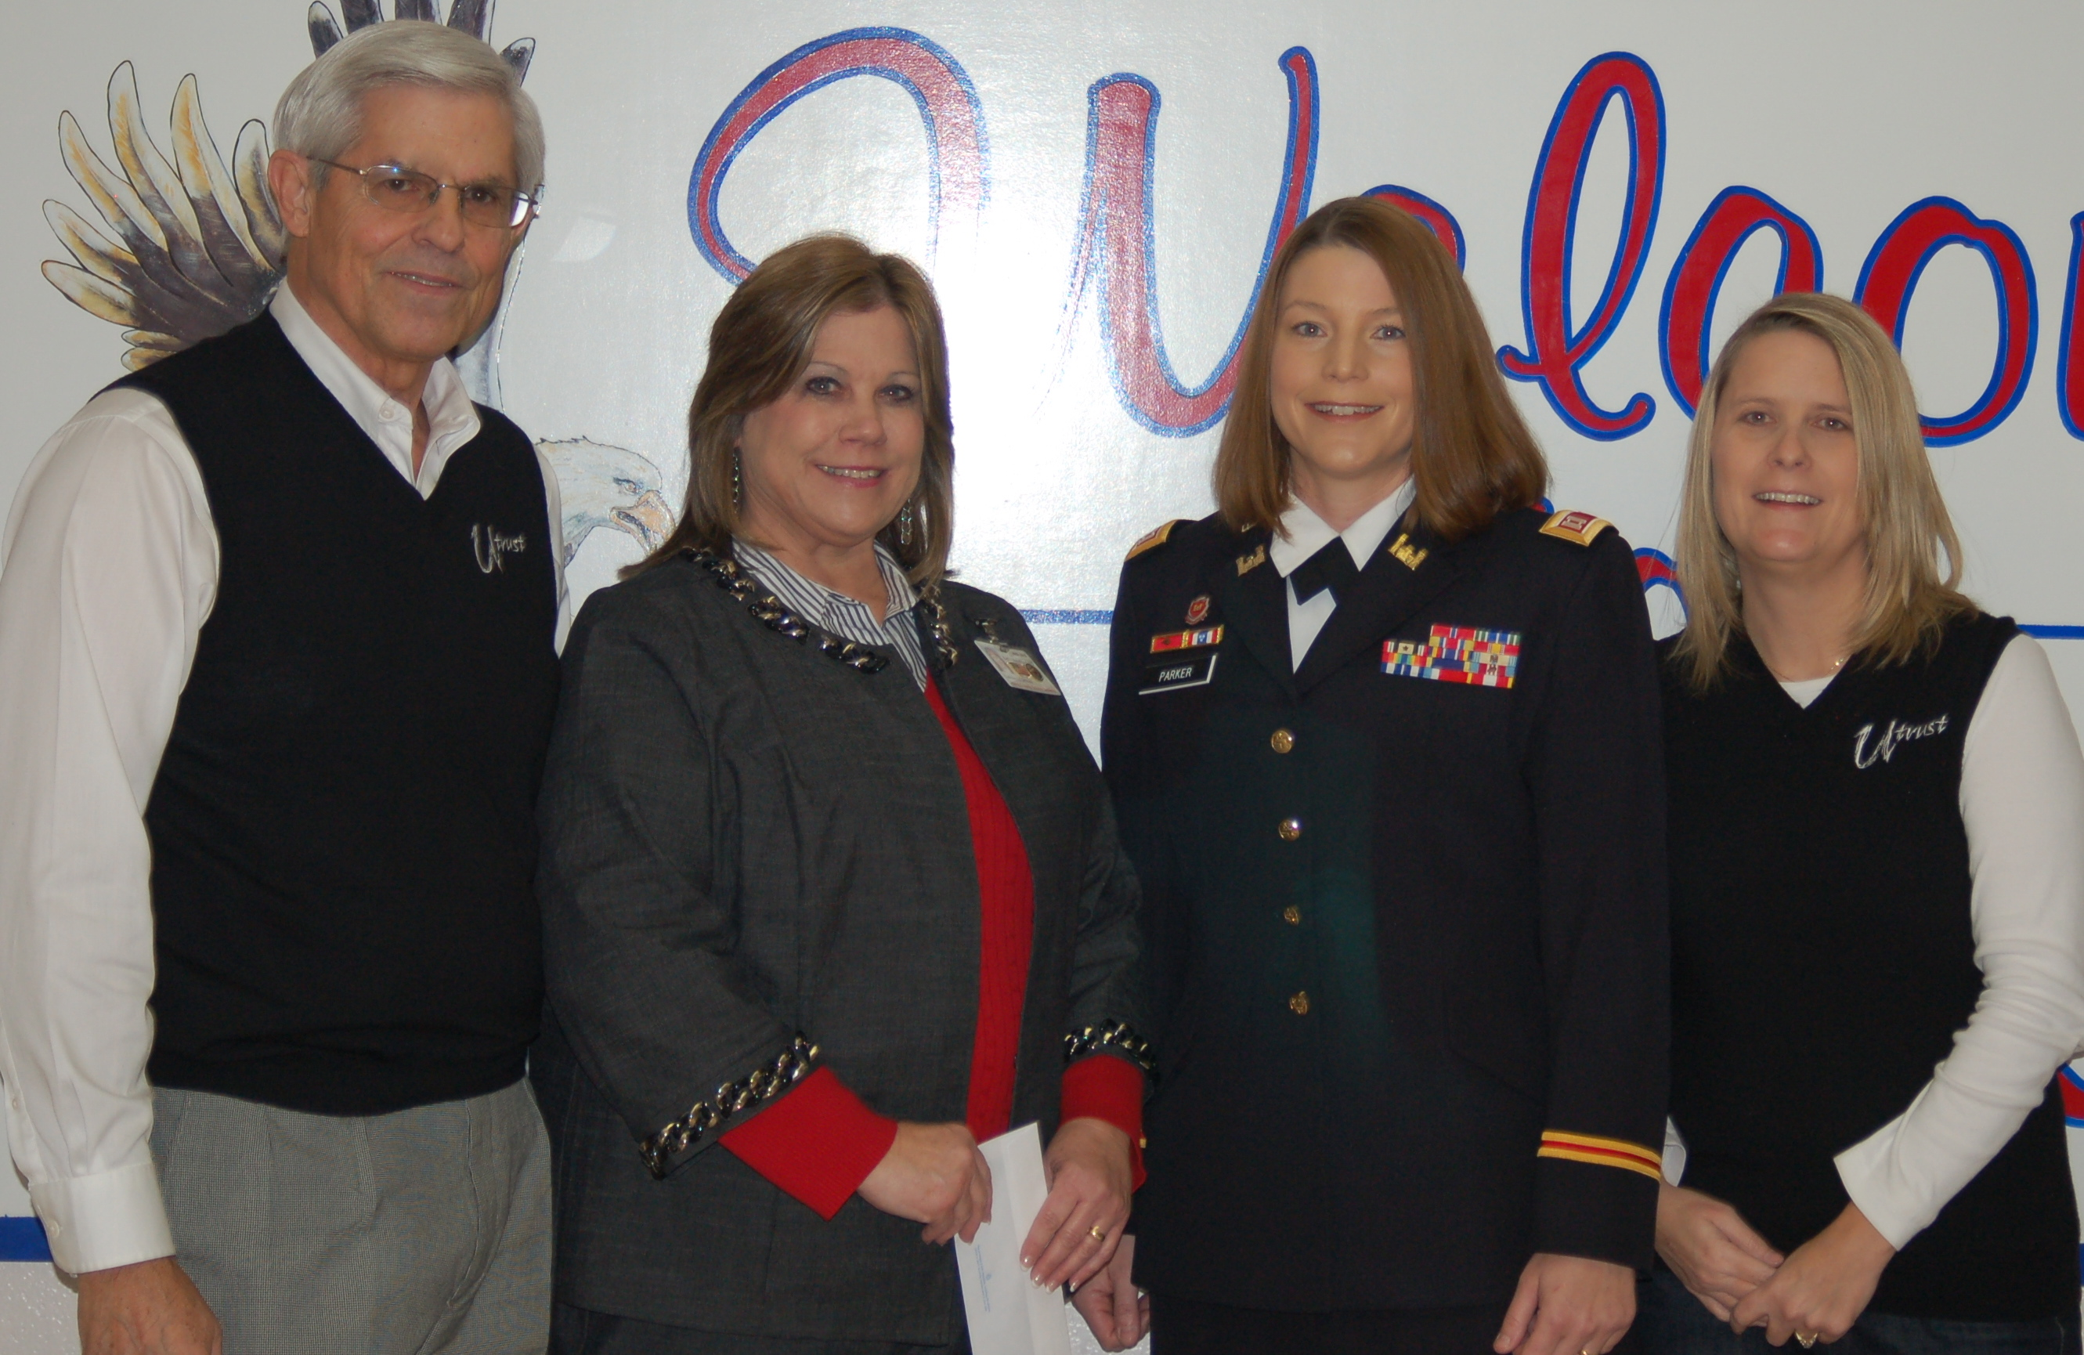
###
Dr. Dan Tollett, Beth Weatherford, Susan Parker, Kristi Coleman

